Goals:

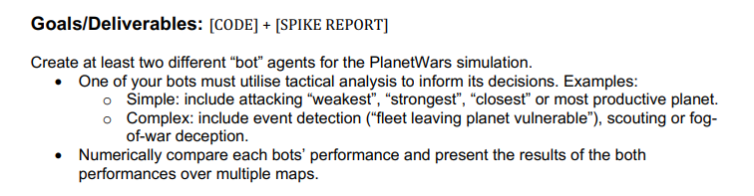

Technologies, Tools, and Resources used:

* Python IDE (PyCharm) with Python 3 installed
* Pyglet Documentation here: http://pyglet.readthedocs.io/en/pyglet-1.3-maintenance/
* Help from peers.
* Python 3 Documentation http://docs.python.org/
* The Lab 04 work was used as a base for the spike
  + One of the bots from this work “Simple_Stratigic.py” is used as one of the bots as it uses simple analysis to determine the planet to attack
  + The other bot used is the “Rando.py” which just attacks randomly

Task done:

1. Got the main function to run for a set number of times for testing the bots and getting the number of wins for each.

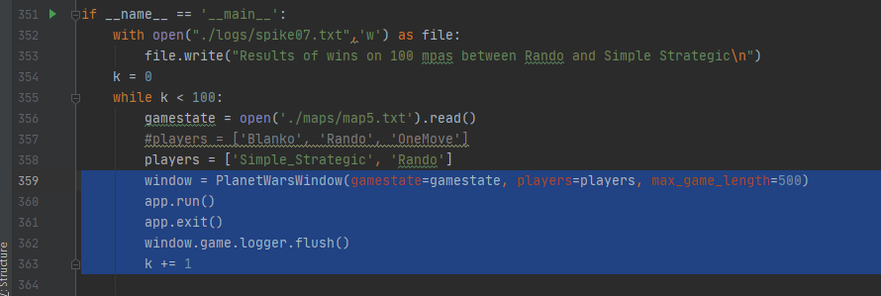

1. Updated the update function in main to amend the text file to record wins and name.

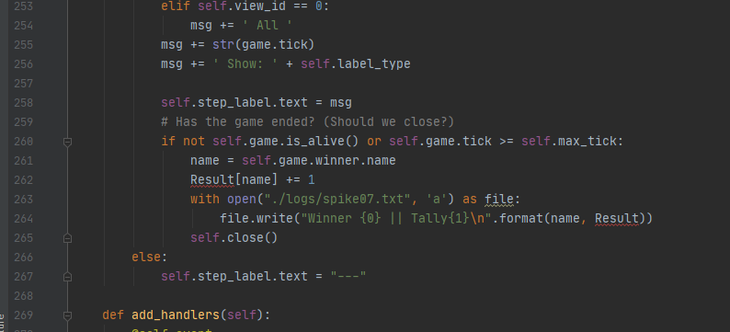

Output we found out:

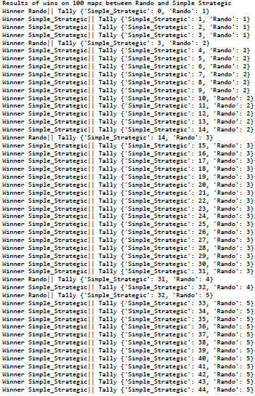

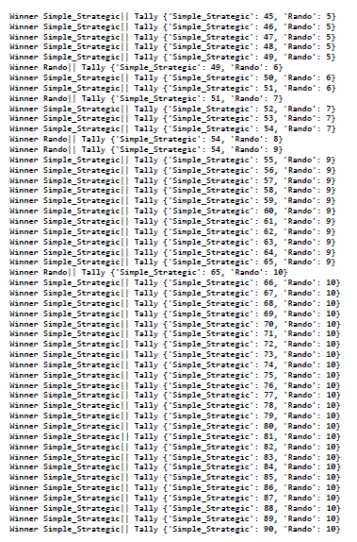

These above results are from running this game a set number of times as stated in the code, the results can be clearly seen that the strategic bot hat more than 80% win rate as compared to rando which was a random bot so the results would be a little non-deterministic despite that simple strategic were generally good with many maps.